|  |
| --- |
| **Using GIS for Solving Traffic Congestion Problems in King AbdulAziz University** |

**Table of Contents**

**Literature Review3**

**Aims and Objectives4**

**Approach5**

Dataset6

Flow Chart5

Detailed Process7

**Software Used21**

**References21**

**List of Figures**

Figure 1 6

Figure 2 7

Figure 3 8

Figure 4 8

Figure 5 10

Figure 6 10

Figure 7 11

Figure 8 11

Figure 9 12

Figure 10 12

Figure 11 13

Figure 12 14

Figure 13 15

Figure 14 15

Figure 15 16

Figure 16 16

Figure 17 17

Figure 18 18

Figure 19 19

Figure 20 19

Figure 21 20

Figure 22 20

Figure 23 21

**Using GIS for Solving Traffic Congestion Problems in King AbdulAziz University**

**AIM: To find out a suitable path keeping in view the traffic count and time from the different gates of the university.**

**Literature Review:** Traffic management is one of the most difficult tasks undertaken by the local authorities because of the rapid urbanization that the world is currently facing. Poor and inadequate traffic management and planning leads to traffic congestion and increasing number of accidents that is an alarming situation not only in terms of financial losses but also for human lives. Therefore, the adoption of modern technology in traffic management is necessary in order to manage the current traffic scenarios and to find the effective solutions to the suffocating congestion and traffic accidents [1].

GIS is a logical, intuitive and powerful way of storing, processing and retrieving data. In addition to enhancing the connection between different types of data and maps, GIS can visually display and control many types of data for the ease of understanding, with high monitoring, and other capabilities required by studies that deal with large amounts of spatial and descriptive data [2].

Nowadays GIS has acquired enormous quantity of traffic and transportation data through various streets and intersections, because of the innovative technologies and knowledge that are fundamental for the traffic modeling and simulation and has been viewed as the potential foundational information stage of traffic simulation [3]. GIS is one of the powerful tools in the analysis of spatial and temporal data, which gave it the ability of effective traffic management. GIS used global positioning data to determine the location of traffic congestion and other spatial information related to traffic congestion. It plays a vital and articular role in the solution and management of traffic problems, as the application of GIS has helped to determine the level of access to public transport [4]. The efforts of modern scientists have focused on developing a range of tools and techniques that they can use it to beat traffic challenges and to assist in planning and decision-making. (GIS-T) has evolved over the years as one of the most efficient tools for planning, research and transportation management [5]. Since the wide spread of GIS-T, many scientists and specialists are focused in doing studies and models that simulate the current traffic situation and help to solve traffic problems. As examples, we find that the research presented in the study [6], searched for the significance of real-time traffic information collected through GIS to optimize the routing of the vehicle within a dynamic random transport network. These characteristics would offer assistance for users and motorists to improve productivity and level of service as long as the web appli-cation allows them to interactively discover the optimal route for their destinations. Advani [7] established a GIS-based model to reduce travel distance and user travel time. Constraints were taken into account, as impediments of intersections, velocity and the sort of road. It is stated that GIS is an effective tool to solve those complex problems in an accurate and quick way. Recently, King Abdul Aziz University in Saudi Arabia witnessed severe traffic congestion problems extending from Jeddah's sub-streets through the university's surrounding streets, reaching to the university gates and entrances. All the traffic plans pre-pared by the traffic authorities in cooperation with the university security failed to contain this traffic congestion through and inside the roads of the King's University Abdul Aziz. According to a report [8], the plan developed by the traffic men in coordination with the security of the University, which is the closure of some university gates and enable the movement through other gates in order to unify traffic and create a smooth flow of vehicles, has been failed. In addition to its failure, the plan developed adverse results that increased traffic congestion in front of the gates and prevented students and university professors from reaching their lectures on time.

Although of this widespread of the GIS-T applications in the developed countries, it is still having a limited application in developing countries, due to the constraining factors such as inadequate expertise and initial prohibitive costs [5].

Thus, this research will be conducted in order to solve this traffic congestion problem through King Abdul Aziz University in Saudi Arabia, which is in one of the developing countries that use GIS technology in a limited way in the management of traffic, in order to demonstrate the importance of this system in traffic management and its great role in solving King Abdul Aziz University's traffic congestion.

**Aims and Objectives:** The main objective of this project is "Solving Traffic Congestion Problems in King Abdul Aziz University Using GIS". which is divided into the following subdivided objectives:

* To manage the traffic volume at jammed locations and congested roads in the study area.
* To identify how GIS works and how could be used in the transportation systems.
* To establish a GIS database for the traffic volume.
* Try to decrease the traffic congestion and to identify and resolving the problems by a GIS based model.
* To define the alternate routes and determine substitute routes for effective traffic management.
* To develop an assistance system that uses GIS for the purpose of analyzing and reducing efforts.
* To identify the effect of GIS on the decision-making process.
* To clarify the difficulties that could face the GIS work and the limitations of this system.

**Approach:** This research tends to use the extension of Esri ArcGIS called ArcGIS Network Analyst in order to achieve the main aim and the purposes of this study. It provides network-based spatial analysis tools which are very helpful for solving complex routing problems. It provides a configurable transportation network data model that can be used by organizations to accurately represent their unique network requirements.

We have three possible scenarios in order to find the best route from the gates of university. As we want to find the best route between two points, the beginning point will be the initial point indicated and the destination point will be the point where we want to go. Now the definition of the best route varies keeping in mind the below defined scenarios:

1. One way to define best route is the smallest distance between two points.
2. One way is selecting the path with the least amount of traffic.
3. One way is selecting the route that gives the minimum amount of time to reach the destination.

If we keep in mind only the first point, there are some drawbacks. Because in this scenario we are totally neglecting the count of traffic and the time that will be required to reach the final point. In this case there can be a scenario where the distance between two points is comparatively very less, but the traffic count is high that will cause in the concession of the traffic so, more time will be taken. Second point is relatively more beneficial as we are keeping in view the count of traffic and in this way the system will select the less congested path for travelling that will ultimately result in reaching the destination in less time. The best case among all the three scenarios is the third point, where time is taken into account for selecting the path. The third point is more attractive and appealing because it is considering the limits present in the first two point and dealing with them. It is considering the time to move from one point to another. For example, there are two paths to reach from point one to another. Path one represented by P1 has a small distance, but the traffic is congested on this path. There is a path two represented by P2 where there is no blockage of traffic, but the distance is more. So, in this case the overall time to reach the destination point will be calculated and the path with less time will be assigned by the system.

The following methodology was adopted in order to answer the main research question:

* Preparing the base map for the study area.
* Identifying study area's traffic congested location.
* Collecting of traffic volume data.
* Doing GIS classifications.
* Detecting of new routs as an alternative of congested routes by a tool called "Network Analyst".

The analysis of the expansion of transport infrastructure was considered in three categories of transport: main and secondary roads in the university and the university gates and entrances.

**Dataset:**

The base map would be prepared by the researcher using high resolution satellite image. Then, the researcher will conduct an inspection survey in order to determine the specific locations through the study area where the congestion problem occur. Depending on the field study, the congestion locations would be identified through the traffic volume survey. After that, the data that was collected by the survey is integrated into the GIS platform.

The network dataset and other required data for this project is provided by GIS Department in King Abdul Aziz University and the Municipality of Jeddah. The data is available in the form of number of vehicles passing through different gates at different times of a day. The data that is used for the training of the system represents the traffic of eight days with an interval of fifteen minutes.

**Flow Chart:**

Figure 1

**Detailed Process:**

The Network Analyst extension has to be enabled.

Create the base map of the required location with proper attributes table.

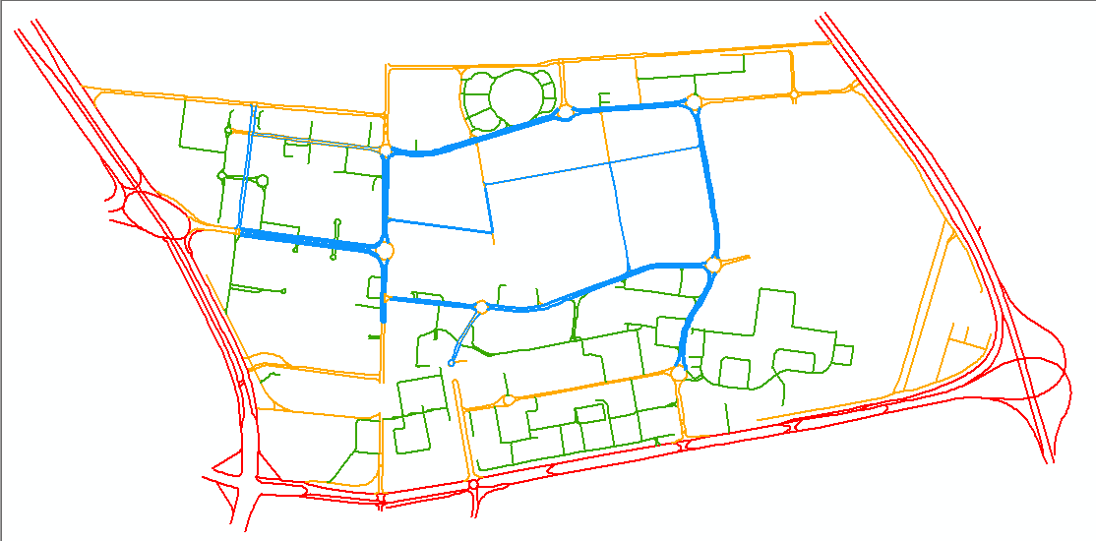

Figure 2

Add the traffic data of the gates in the shapefiles.

Build a Network Dataset from the base map.

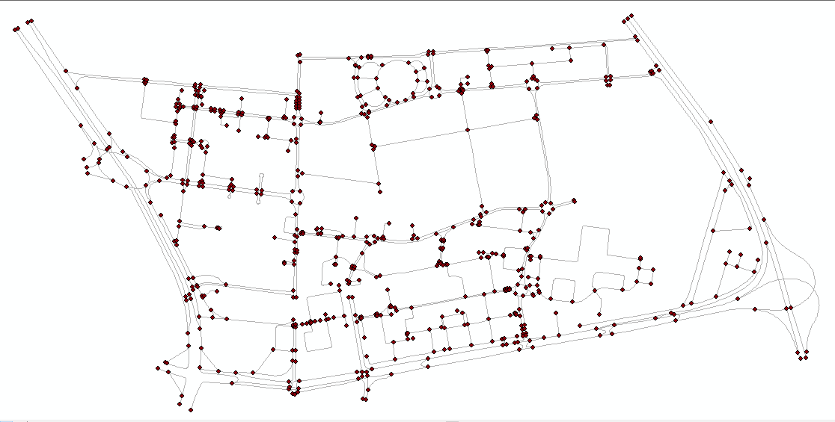

Figure 3

Include traffic details in the network dataset.

Restrict the roads with major traffic on Network Dataset.

Train Network Dataset Model according to the traffic count at gates and links provided in the data.

Add two points on the network dataset and run to obtain the shortest path.

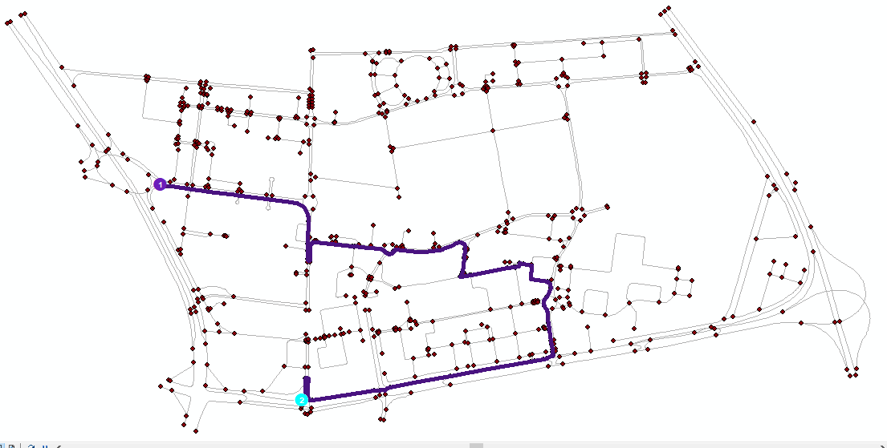

Figure 4

Now we must train the network data set according to the traffic data. For that we have to Change the data so that we can use it in ArcMap.

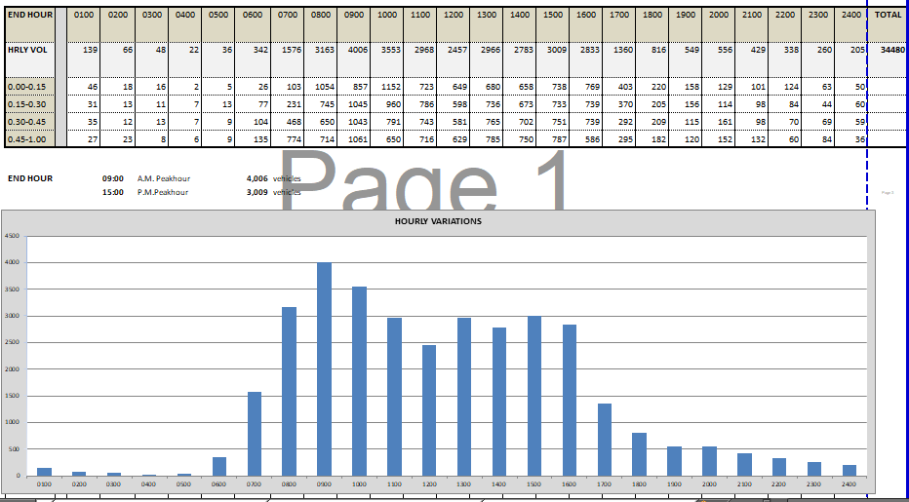

Figure 5

In the **Figure 5** given above we can see the data of one of the gates on some specific day of the week. This data will be changed into a form of speed multiplier.

To change the data to speed multiplier we used a formula for every time slice such that we got maximum traffic of a specific time slice and subtracted the value of all x’s (x is the value of all gate traffic) and then divide it with maximum value. This gives a value between the range of 0 and 1.

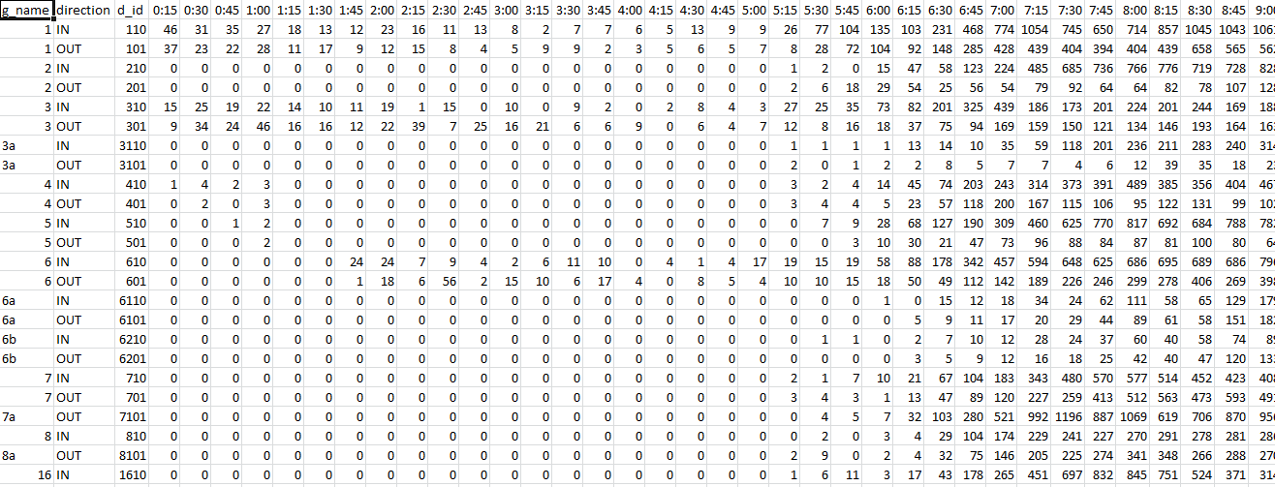

Figure 6

Traffic Count Data as shown in **Figure 6** is converted to multiplier form so that it can be used in ArcMap Historical traffic model in network analyst. Converted data can be seen in **Figure 7**.

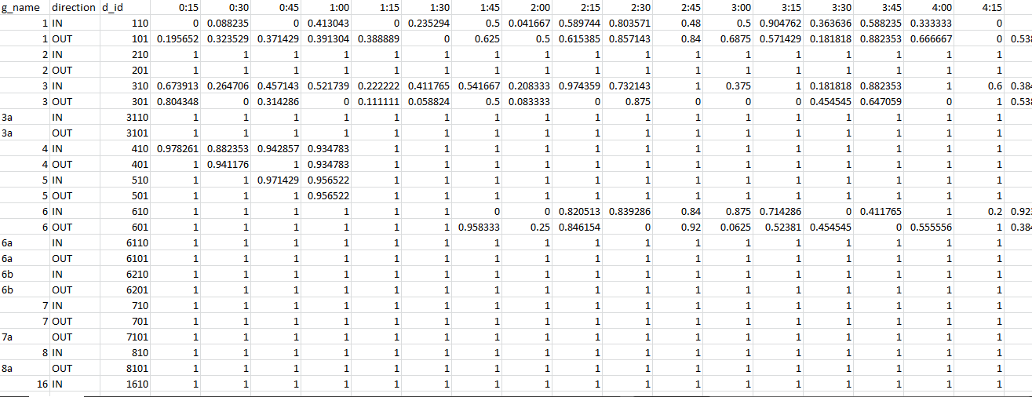

Figure 7

Now to train the model according to the traffic there are three file requirements.

* Daily Profiles Table
* Street Profiles Table
* At least one file with edges to train on

We've a profile for Sunday; we need to repeat the process for the other days of the week. To do that, process is:

* Observe or calculate the free-flow travel speeds on the street segment.
* Observe average speeds for equal intervals throughout the day.
* Convert the speeds to a scale factor (between 0 and 1) of the free-flow speed.
* Choose a profile to represent the street segment's traffic for that day of the week.

Now we will begin training the model. For that first we have to put all our files into a geographical database. In that geographical database we will have a feature dataset that will include those files that will be used in training the model. And in the geographical database there must be two tables containing the traffic data. Figures below shows the files described.

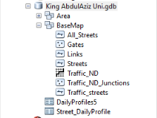

Figure 8

Daily profile table has all the historical traffic multiplier values of al days of the week with an interval of 15 minutes.

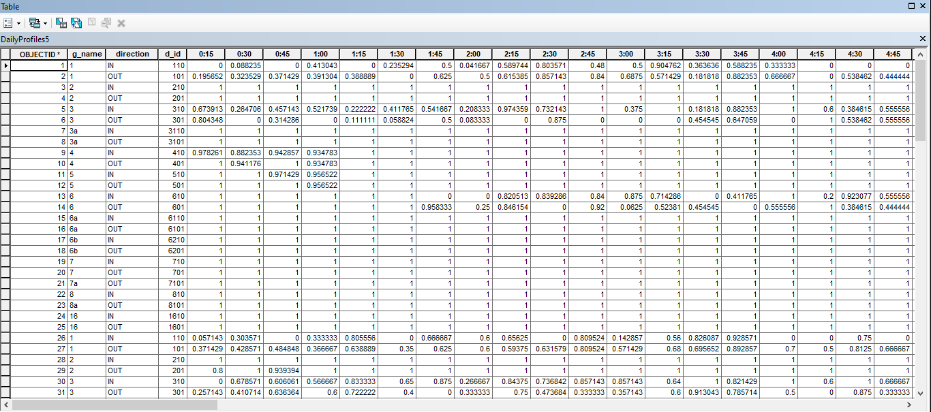

Figure 9

Street_DailyProfile table includes the FID of the edges on which this traffic is. Each feature class in ArcMap is assigned an ID. In Street_DailyProfile Table the ID of the feature class having the edges must be included. We can get the assigned ID in the properties of the feature class. In properties, general tab we see three dots in front of name, by clicking there we can get ID.

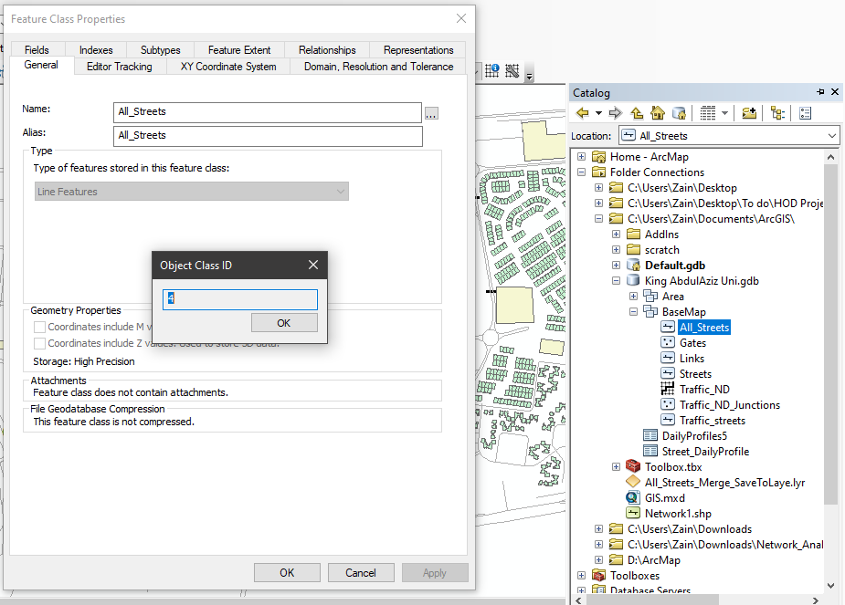

Figure 10

Now this ID will be used in Streets_DailyProfile Table.

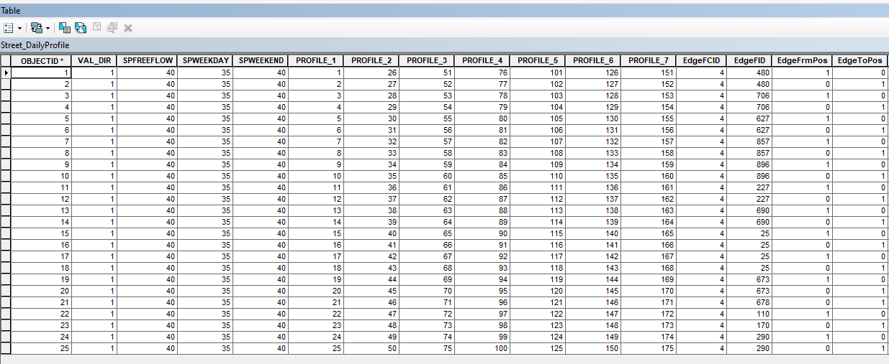

Figure 11

As shown in the Figure 11, in column FCID(Feature Class ID) will be entered the Feature Class ID we got, which in our case is 4. In EdgeFID, will be the ObjectID of the edges of that feature class on which traffic is. In **Figure 12**, each column is of some specific day. 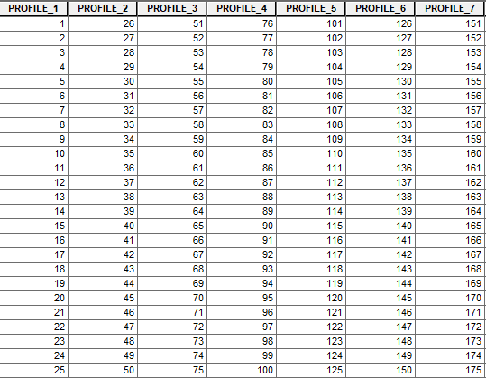

Figure 12

To create a Network Dataset with historical traffic we will right click on the feature dataset.

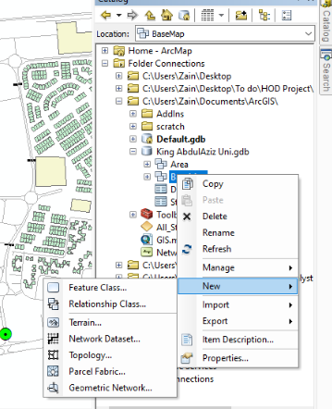

Figure 13

Click on Network Dataset in new.

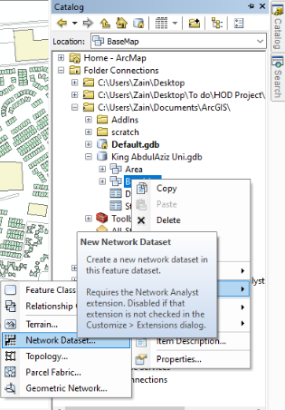

Figure 14

Now we have to select the sources for the network dataset. For this project these sources were included.

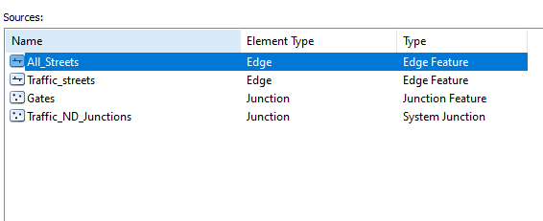

Figure 15

After this, connectivity of the data should be provided to dataset.

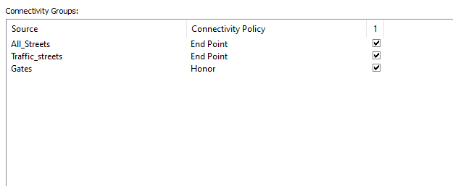

Figure 16

Also we have to give the fields that have the elevation values for determining bridges.

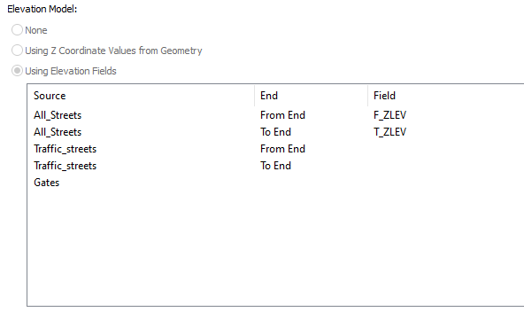

Figure 17

In the next step, traffic data will be added to the dataset. It won’t ask for traffic data until requirements are met. Req. also includes some specific fields in the table with some specific names. There are only two types of profiles.

* Speed
* Time

In speed profile it needs the data as multiplier of speed due to traffic. Multiplier must be in range of 0 to 1 for the dataset to have better performance.

In time profile it needs the data of the time consumed by vehicles in traffic.

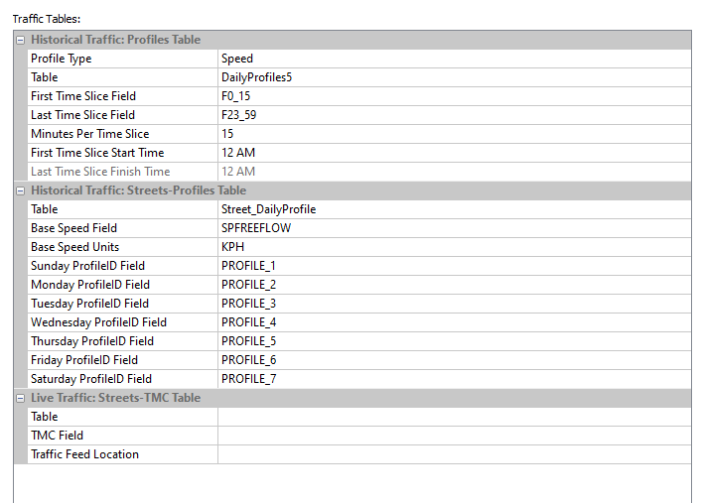

Figure 18

Now attributes will be added to the dataset on which basis the dataset will be trained and will provide us with visual traffic and route. In the figure, we can see the attributes I used. There are total 4 types of attributes.

* Cost
* Hierarchy
* Restriction
* Descriptor

All 3 types effect on its route providing factors except descriptors. I have used Time, length and traffic in the model as cost. Subtype as hierarchy. One way and Restriction as restrictions.

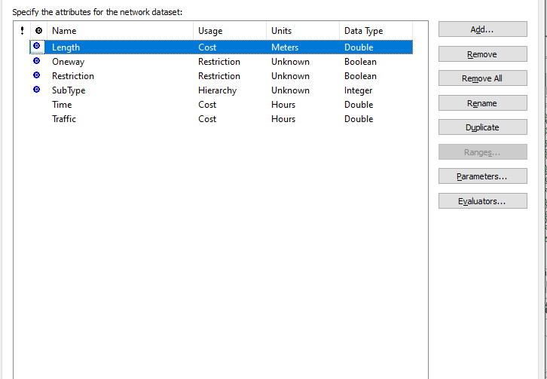

Figure 19

After having the attributes, there is the need to create the travel mode. Travel mode can be based on either traffic or only the time or length attribute. We have used traffic, length and time in our travel mode.

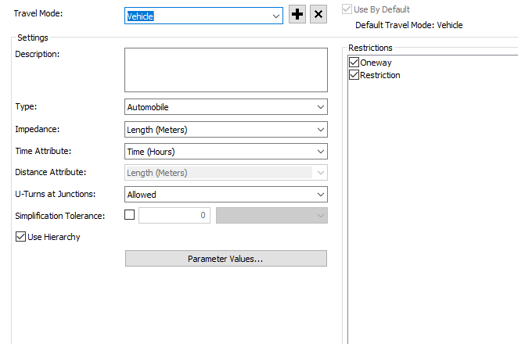

Figure 20

After training the dataset we can see all junctions, edge, traffic on the base map.

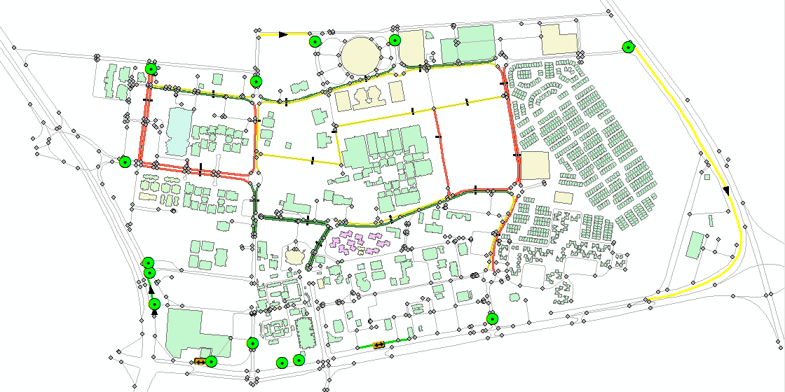

Figure 21

All the red lines are high traffic area, yellow are of moderate traffic and green are light traffic. Now that the dataset has been trained, we can also see the traffic at different time of the day by time slider.

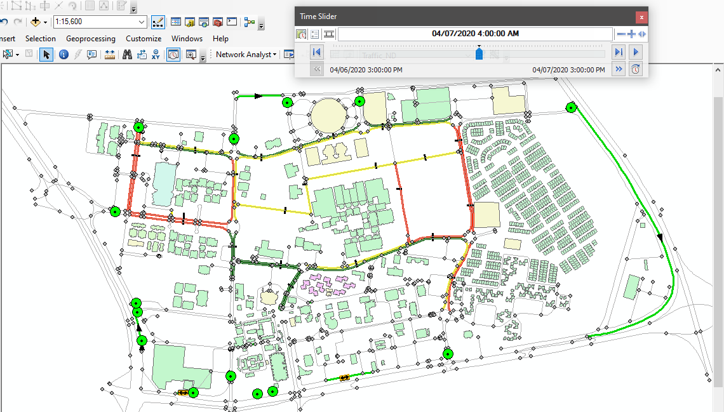

Figure 23

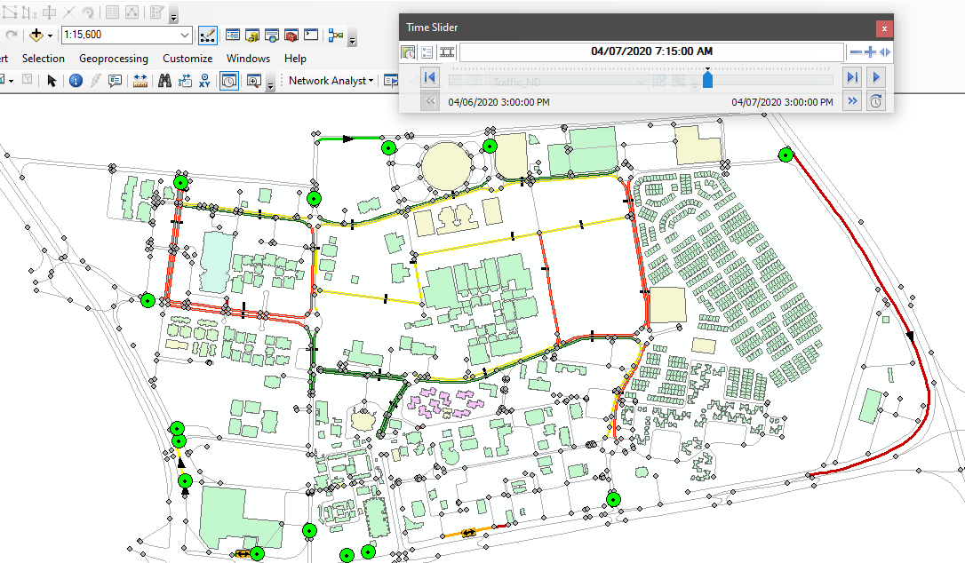

Figure 24

As we can see from the figures above that on different time there is different traffic according to the model, we trained with the historical traffic data.

Now that the traffic data is also included and the route will be different as compared to the route without traffic data.

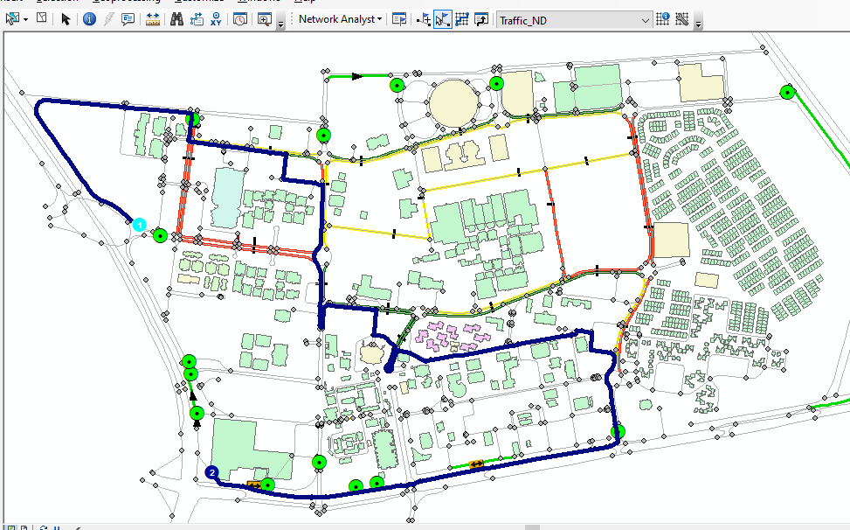

Figure 25

## Steps to create route:

1. Right click on the toolbar and select Network Analyst.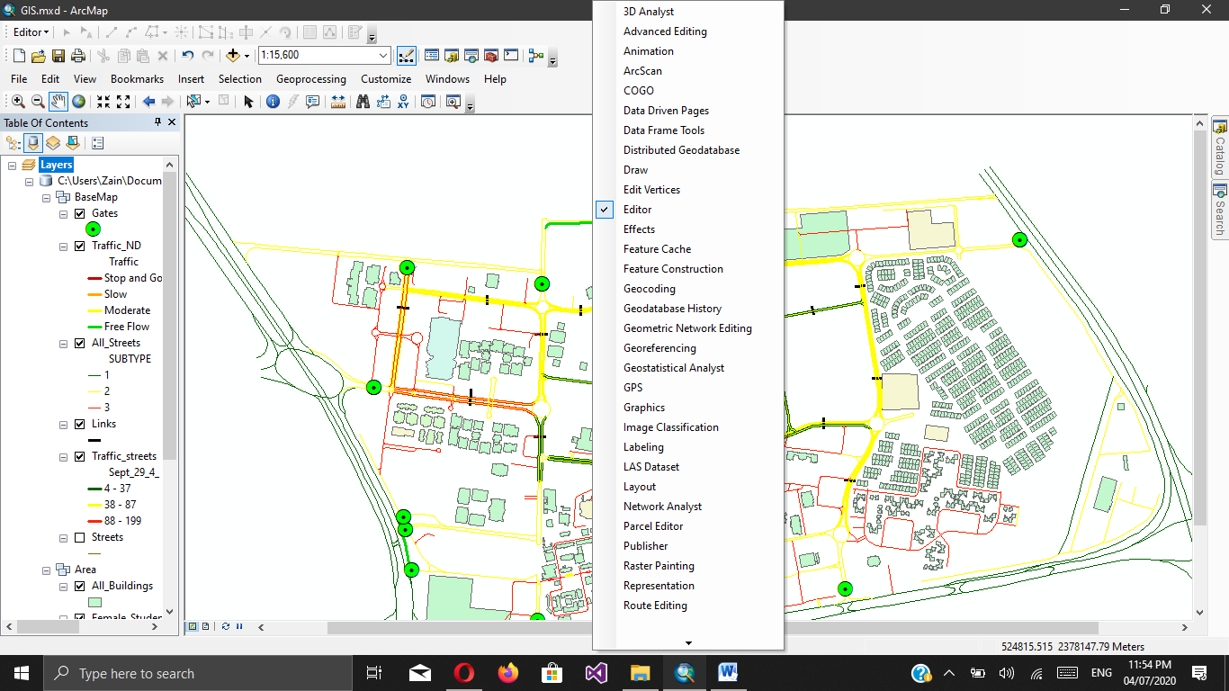
2. On Network Analysis toolbar open dropdown menu and select new route.

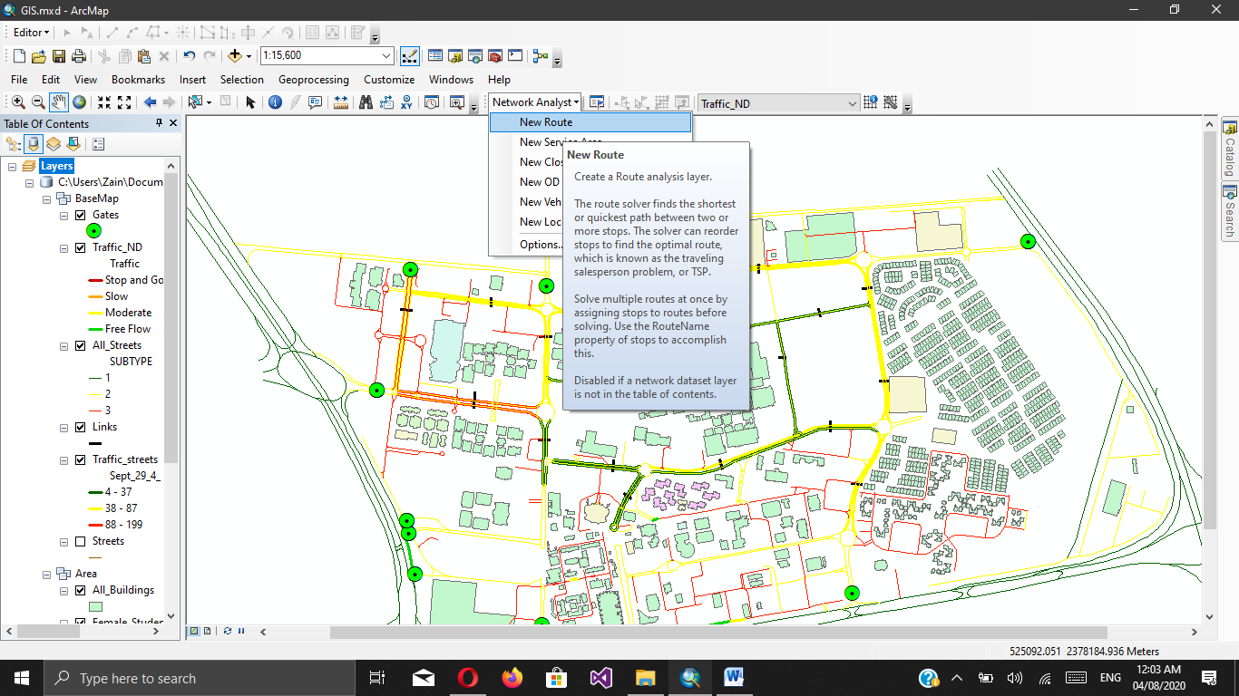

1. Now select the create network location tool(highlighted in yellow) from the Network Analyst toolbar.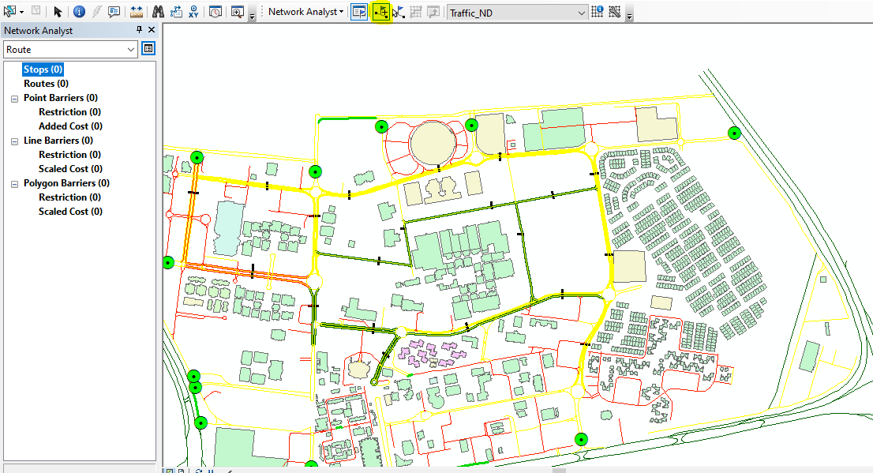
2. Add location point, stop points and the destination point. 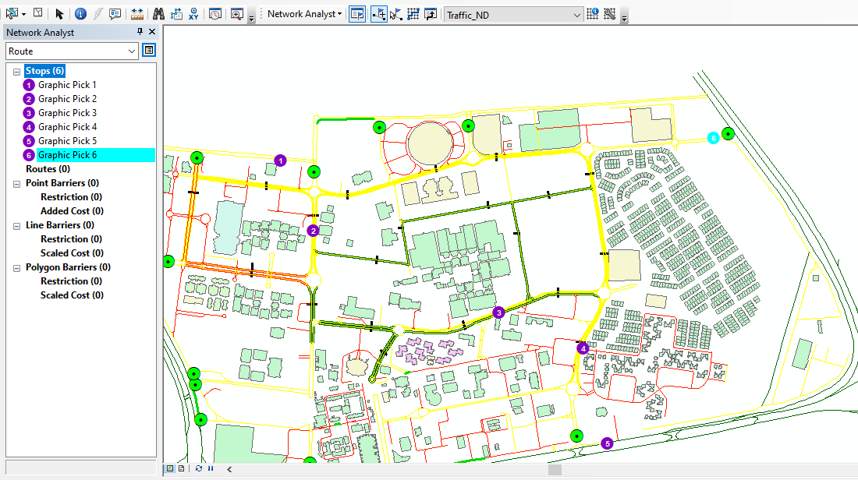
3. Click on the solve(highlighted in yellow) to create the route between points. 
4. Trained network dataset will generate the route according to the cost attributes. 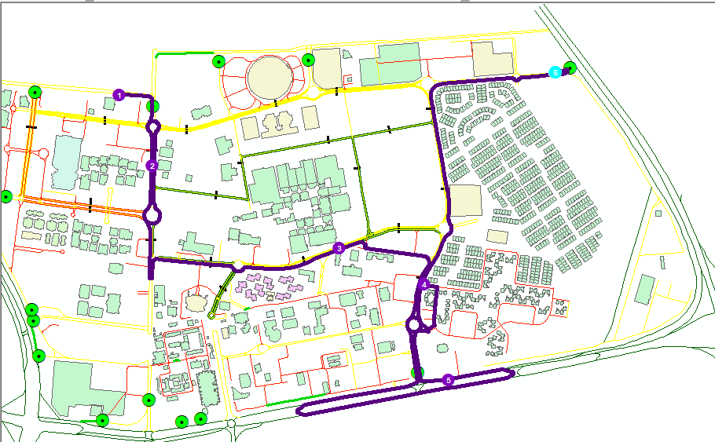
5. To view the traffic by provided historical data you can open the time slider toolbar. 
6. Click on enable time to visualize the traffic on the basis of time. 
7. You can slide the time and check on which time you want to see the traffic.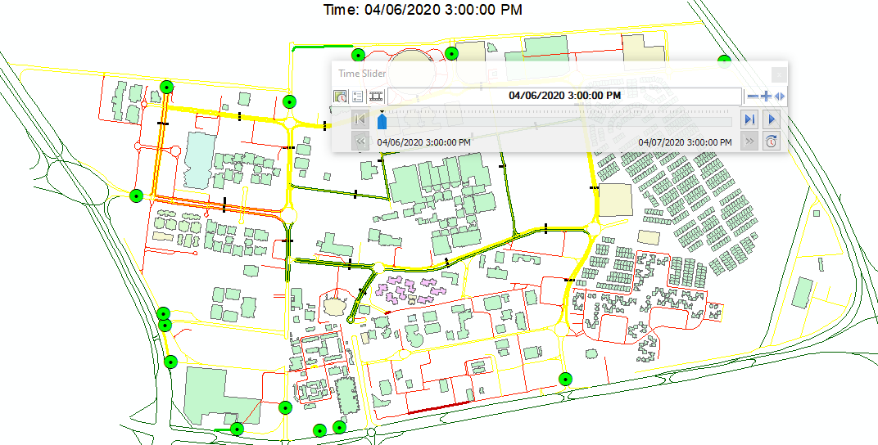
8. Also for any addition of attributes in network dataset. You have to go in the properties of your network dataset from catalog. 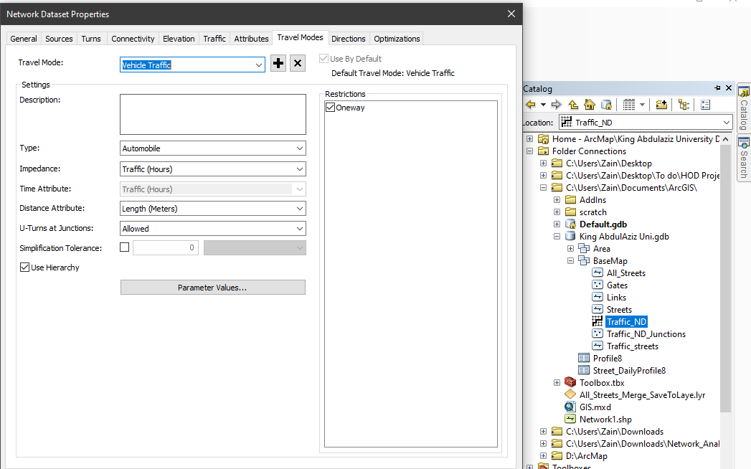
9. Go to the attributes tab. 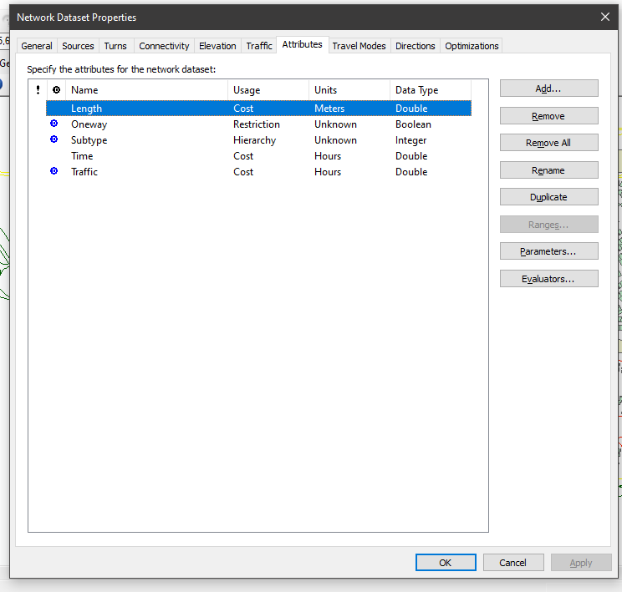
10. Here you can add new attributes.

**Software used:**

* ARCMAP 10.6

**References:**

1. Sureshkumar,M. ,Supraja,S. and Sowmya,R.B. (2017). GIS Based Route Optimization for Effective Traffic Management. IJERM, International Journal of Engineering Research and Management, Volume-04, Issue-03, March 2017.
2. Sofia, A.S.S.D., Nithyaa, R. and Arulraj, G.P. (2013). Minimizing the Traffic Congestion Using GIS. IJREAT, International Journal of Research in Engineering & Advanced Technology, Volume 1, Issue 1, March, 2013.
3. Malgundkar, T., Rao,M. and Mantha,S.S. (2012). GIS DRIVEN URBAN TRAFFIC ANALYSIS BASED ON ONTOLOGY. International Journal of Managing Information Technology (IJMIT)Vol.4, No.1.
4. Sunday, O. M. and Ademola,O.J.(2016). GIS application for determining public transport access level in the Federal Capital Territory (FCT), Abuja-Nigeria. Journal of Geography and Regional Planning, Volume9, no. 8, pp. 154-163.
5. Agyemang, E. (2013). A cost-effective Geographic Information Systems for Transportation (GIS-T) application for traffic congestion analyses in the Developing World. Ghana Journal of Geography Vol. 5, Pages 51 – 72.
6. Alazab,A. , Venkatraman,S., Abawajy,J. and Alazab,M.(2011). An Optimal Transportation Routing Approach using GIS-based Dynamic Traffic Flows. 3rd International Conference on Information and Financial Engineering, vol.12, IACSIT Press, Singapore, pp172-17.8.
7. Advani,M. , Srirama, B. and Pathan,S.K.(2005). Improvement in Transit Service using GIS – Case study of Bhavnagar State Transport Depot, Proceedings ESRI National Conference held at NOIDA, India,pp1-7.
8. Al-Saqqaf, Anwar (2016). Traffic congestion .45 minutes to bypass the gates of King Abdul-Aziz University. Al Madina Newspaper, available @: http://www.al-madina.com/article/470529/